**Razor Pages**

**1. Create a welcome page:**

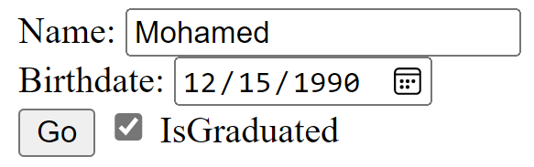



**2. Greeting Card Maker:**

a. Background design [provided in the folder]

b. There is a static picture for every greeting type [provided in folder]. (note: the checkbox is an option given to control the picture visibility)

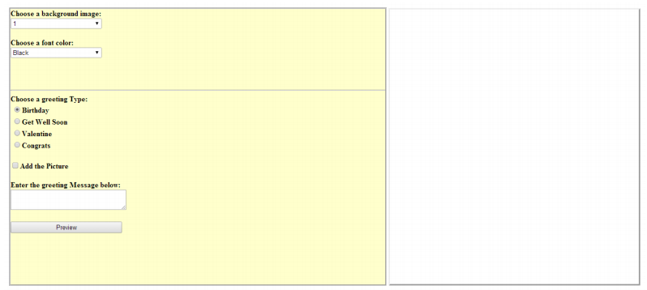

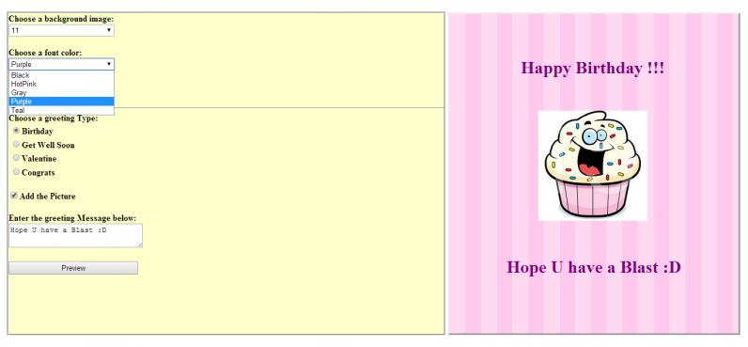

**3- try to search for a “Professional template design”, then create a Layout template for your pages, apply it on all the pages (using _PageStart)**

**4- try to use (webGrid helper) and any other helper of your choice**